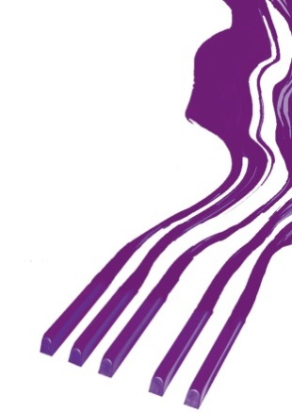
REZULTATI KLAVIR SOLO/RESULTS PIANO SOLO

BABY KATEGORIJA/BABY CATEGORY

Takmičar/Competitor | Datum rođenja/Date of birth | Ilia Tchernaev | Olga Borzenko | Dragomir Bratić | Irina  Mints | Ocena/Points | Nagrada/  Award
1. Sophia Maddock  Dr Ina Selvelieva | 30. 4. 2014. | 100 | 100 | 100 | 100 | 100 | I-1
2. Ploypitcha  Sinhirunwiwat  Prof. Thawanhathai  Rujichaitammakul | 26. 2. 2017. | 100 | 100 | 100 | 97 | 99,25 | I-2
3. Marta Stanković  Prof. Hristina  Lazarević Suton | 18. 11. 2014. | 100 | 100 | 100 | 96 | 99 | I-3
4. Tara Lazić  Prof. Ivana  Todorović | 15. 12. 2015. | 97 | 94 | 94 | 93 | 94,50 | I-4
5. Tunamal-Erdene  Batzorigt  Prof. Tsatsral  Odonkhuu | 5. 3. 2014. | 96 | 93 | 92 | 90 | 92,75 | I-5
6. Ninjin Bat-Erdene  Prof. Tsatsral  Odonkhuu | 16. 10. 2015. | 94 | 93 | 93 | 90 | 92,50 | I-6
7. Karina Hristova  Prof. Sava Vutov | 24. 11. 2014. | 95 | 91 | 91 | 90 | 91,75 | I-7
8. Bella Krizsán  Prof. Jácinta Farkas | 14. 7. 2016. | 90 | 94 | 94 | 88 | 91,50 | I-8
9. Kinga Emese Váczi-  Delley  Prof. Jácinta Farkas | 5. 3. 2014. | 92 | 92 | 92 | 88 | 91 | I-9
10. Natalija Stojiljković  Prof. Sofija  Stojiljković | 4. 8. 2015. | 90 | 93 | 93 | 85 | 90,25 | I-10
11. Gunchinlkham  Tsendsuren | 4. 4. 2014. | 91 | 90 | 90 | 80 | 87,75 | II-1

Memorial „Sanja Pavlovic“-piano competition
March, 2022, Aleksinac, Serbia

