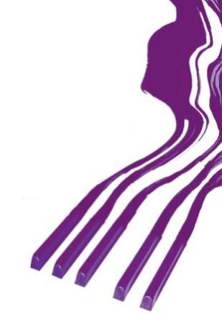
REZULTATI KLAVIR SOLO / RESULTS PIANO SOL

OSMA KATEGORIJA / EIGHTH CATEGORY
Takmičar/Competitor | Datum rođenja/Date of birth | Ilia Tchernaev | Olga Borzenko | Dragomir Bratić | Irina  Mints | Ocena/Points | Nagrada/  Award
1. Yoanna Ivanova,  Prof. Claudio Curti Gialdino | 25. 2. 2000. | 94 | 95 | 97 | 92 | 94,50 | I-1
2. Anđela Spasić,  Prof. Stevan Spalević | 13. 9. 2002. | 85 | 88 | 94 | 90 | 89,25 | II-1

Memorial „Sanja Pavlovic“-piano competition
March, 2022, Aleksinac, Serbia

