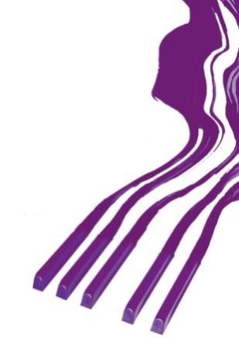
REZULTATI KLAVIR SOLO / RESULTS PIANO SOLO

DEVETA KATEGORIJA / NINTH CATEGORY

Takmičar/Competitor | Datum rođenja/Date of birth | Ilia Tchernaev | Olga Borzenko | Dragomir Bratić | Irina  Mints | Ocena/Points | Nagrada/  Award
1. Katarina Bošković,  Prof. Stevan Spalević | 19. 2. 2000. | 90 | 90 | 90 | 90 | 90 | I-1

Memorial „Sanja Pavlovic“-piano competition
March, 2022, Aleksinac, Serbia

